Pathway
through Pain

A free online course for anyone suffering with
chronic or long term pain.

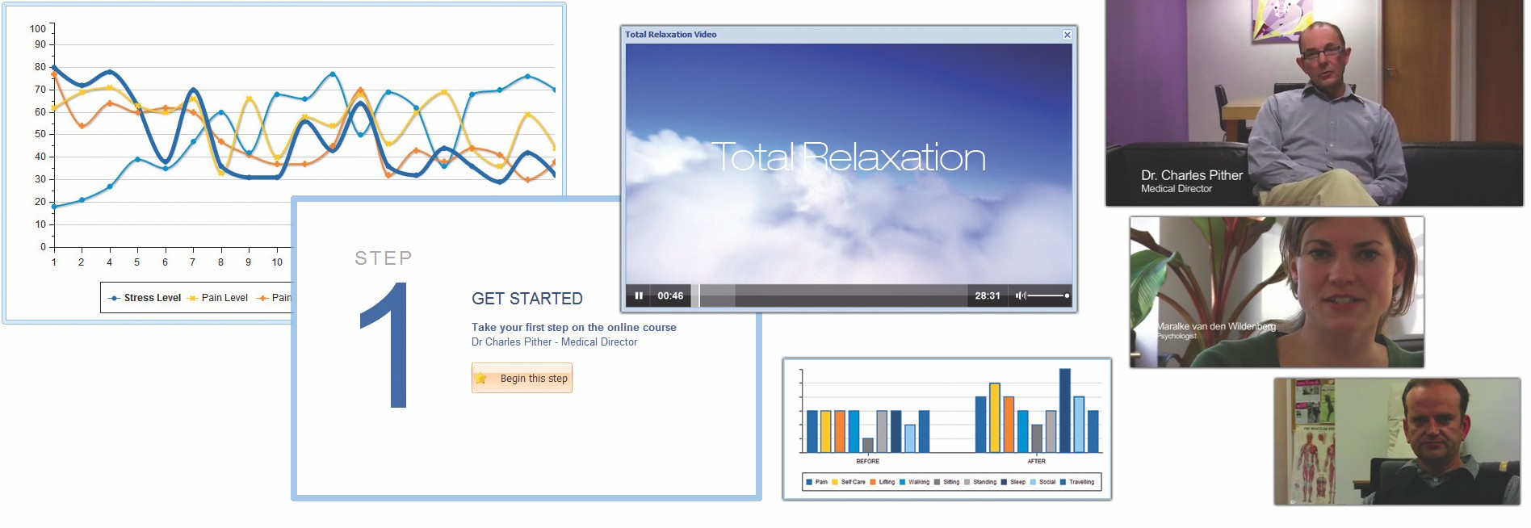

This FREE online course guides you through a set of pain management techniques that help to reduce the impact of pain on daily life.

• Follow the online course at your own pace.
• Understand your pain and fear it less.
• Explore relaxation and mindfulness techniques to reduce pain.
• Improve your body condition with simple stretching exercises.
• Set some goals and work towards them in a measured way.
• Re-examine your thoughts about pain and the situations they occur in.
• Improve your approach to pain recovery activities such as sleep.
• Measure your progress and see what’s working for you.
It's easy-to-follow, with step by step instructions throughout!

Patient’s name:

Patient’s email:

Patient’s gender: Female/Male

Note for clinicians: please email details or this form to Hampshire.Backs@nhs.net

www.pathwaythroughpain.com

